**Lab 1: Resistance, Voltage, and Current Measurements**

**Lab Report by: Talal Jawaid**

**Lab Session: Wednesday**

**Due Date of the Lab: 2/14/18**

**Date(s) of the lab: 1/31/18**

**Lab partner(s): Sergio Zavala and Amrit Singh**

1. **Introduction**

In this Lab we learn how to use the EEE117 Laboratory equipment, specifically the DMM, power supply, and the oscilloscope, in conjunction with our breadboards and a set of resistors. We are to create a set of two circuits. For the first one, we have to measure the voltage across a specific resistor, so that we may observe the voltage drop across the set of resistors. For the second circuit, we are to create a voltage divider circuit so that we may measure the voltage and amperage at different points of the circuit. In addition, we created the circuits on PSPICE so that we could predict what readings we would measure on our actual circuit and then compare these predicted values with our actual measured values.

1. **Purpose**

The purpose of this lab is to see how voltage drops across a circuit, and to observe the amount of current flowing through a specific resistor on a circuit. Overall the purpose of this lab is mainly to familiarize ourselves with the EEE 117L laboratory equipment, so that we may successfully use this equipment in the following weeks for the remaining labs. The purpose of using PSPICE to recreate our circuits on the computer is so that we may be more confident in measurements we make on our physical circuits. If the measurements on PSPICE and the actual measurements aren’t similar, then we will know that something is wrong with either our physical circuit or the circuit on PSPICE.

1. **Discussion and Results**

**Part 1:**

For this part of the lab, we measured the resistance of our resistors and the internal resistance of the 10X probe of the oscilloscope, both on and off.



**Part 2:**

For this part of the lab, we measured the voltage of the source and the voltage across the 100k and 300k Ohms resistors. We measured it once under load and once without load.

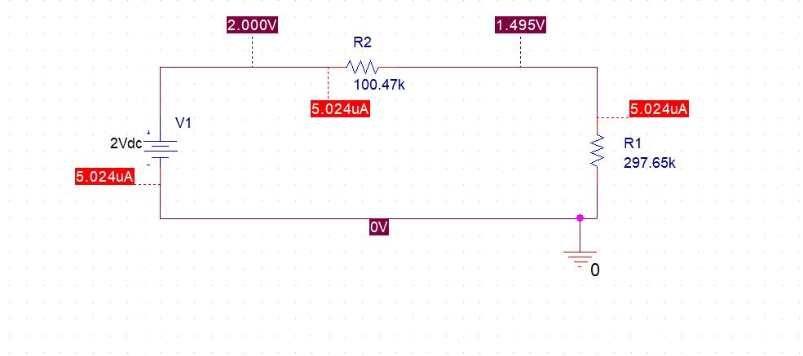





**Part 3:**

We measured the current across the resistors R3,R4,R5 with the multimeter for this part of the lab.



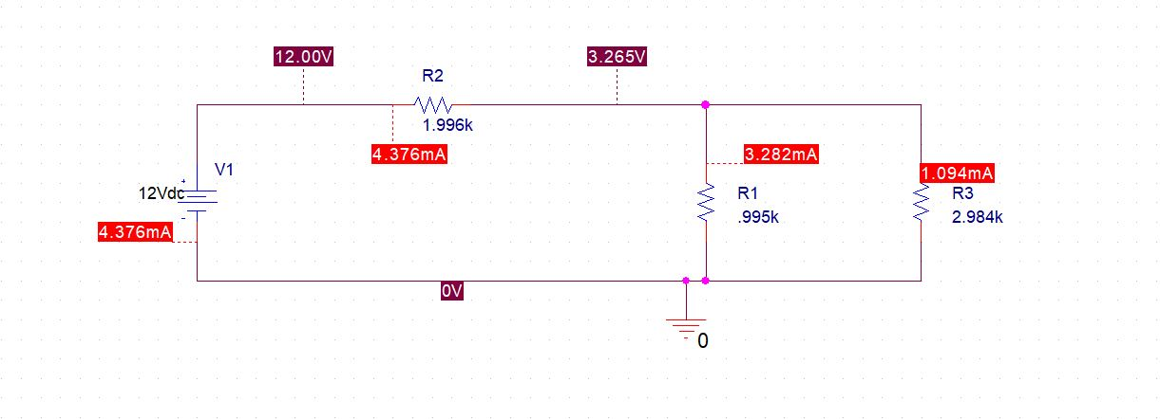

1. **Conclusion:**

In conclusion, we became familiarized with the DMM, power supply, and oscilloscope. We learned how to use these tools effectively so that we may build and design circuits based on circuit diagrams and then measure voltage, current, and resistance values for that circuit. We also learned how to use PSPICE to recreate those circuits on a computer so that we could predict the measurements of current and voltage before actually setting up the circuit. We’ve all used Multisim to create circuits before for a previous class, so we are familiar with how helpful creating a circuit virtually before creating it on a breadboard is. While in this lab PSPICE didn’t save us any time, it will save us a lot of time in the future so that we can determine the best way to set up a circuit before we physically create it on a breadboard.

Kirchoff’s laws were verified as our measurements were very similar to the values on PSPICE. As the circuit was a voltage divider, this verifies Kirchoff’s laws.

Current and voltage division were verified as we used equations to verify the values of the resistors and the resistance values obtained from the voltage and current division equations were similar to our measured and specified values of resistance.

The measured input voltage was exactly the same as the output voltage on the power supply.

All of the resistors were within one percent of the stated values.



If we wanted to disturb the circuit as little as possible, we would use the X10 scope as the X1 scope is stated to be more disturbing to the circuit.